Resource Email Template
*Highlighted fields should be completed by the Approver
Project name:
Send date:
Project Approver:
Audience:
Writer:

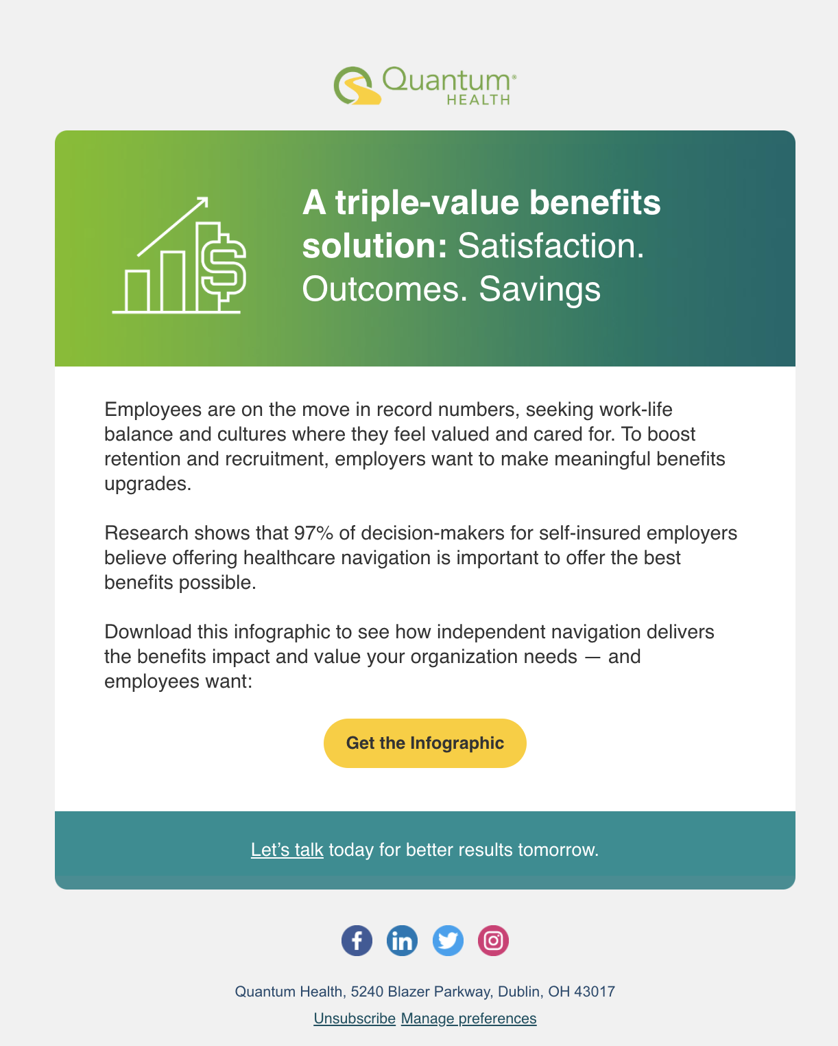 | Icon:
 | Icon color:
 | Subject line A:
Subject line B:
(If applicable)
Title:
The content should be short and concise, no more than seven words. Use sentence case (exception for two words with no exclamation point) and use end punctuation for full sentences.
Body content:
The content should be short and concise, no more than 4 sentences. Keep content to no more than one paragraph per section.
Call to action label:
The label cannot be more than three words and should be descriptive of the action. (ex: Explore Solutions)
 | Call to action link:
Disclaimer:
(If applicable)

